Meal Samples
Breakfast | 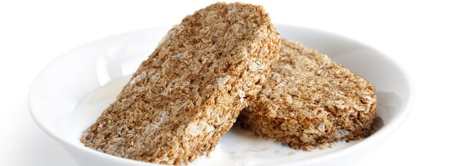  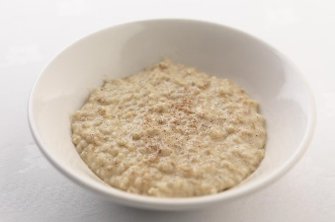  Selection of cereal  Porridge  Toast
Lunch | 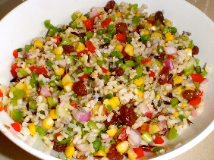  Scrambled Egg on Toast  Rice Salad  Picnic Lunch (sometimes includes homemade bread/scones cakes ect.)  Quiche & Salad  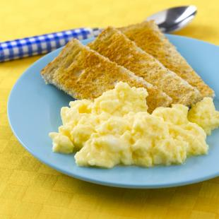  Pasta Salad  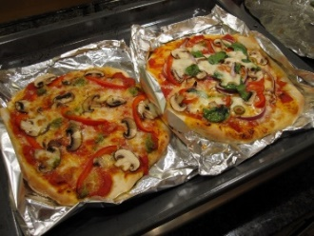  Cream cheese/Ham sandwiches (sometimes made by the children) with veg sticks.  Make your own pizza  Omelette  Soup with bread/rolls  Pesto pasta
Tea | 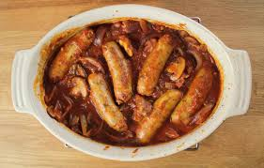  Pasta in homemade vegetable sauce with vegetables.  Make your own pizza with garlic bread & salad  Spaghetti carbonara & vegetables  Beef Casserole  Roast Chicken  Jacket Potato with Cheese & beans or Tuna mayo & sweetcorn  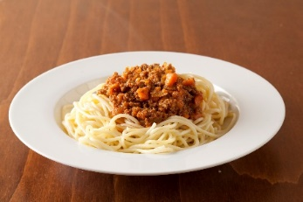  Chicken and Vegetable Kebabs served with Rice  Vegetarian Spaghetti Bolognaise & Garlic Bread  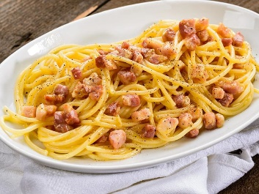  Vegetarian Lasagne & Broccoli  Chicken Curry served with Rice or Noodles  Pasta Carbonara  Cauliflower & Broccoli Cheese  Sausages and homemade wedges & Vegetables  Vegetarian Chilli  Sausage Casserole

